ATM Monitoring System - Component Design

## **Overview**

This document outlines the component design for a service running on ATM devices. The service handles authentication, logs transaction outcomes, and interfaces with a monitor service that manages data storage and access for other bank services.

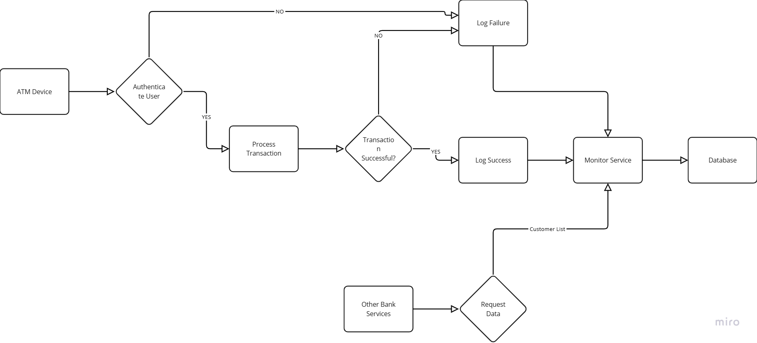

## **Components**

### **1. ATM Device Service**

1. **Purpose**: Handles authentication and transaction processing on ATM devices.
2. **Responsibilities**:
3. Authenticate ATM Device with Monitor Server
4. Process transactions (withdrawals, deposits, balance inquiries).
5. Send transaction success or failure logs to the Monitor Service.

#### **Sub-components:**

**Authentication Module**:

1. Verifies user identity.
2. Interfaces with the bank's authentication server.

**Transaction Processor**:

1. Generates transaction logs (success/failure).
2. Save Video/Image for TimeSamp

**Log Sender**:

1. Formats and sends transaction logs to the Monitor Service.

### **2. Monitor Service**

1. **Purpose**: Centralized service for logging and data management.
2. **Responsibilities**:
3. Receive and store transaction logs, Videos and Images from ATM devices.
4. Provide data access to other bank services.

#### **Sub-components:**

1. **Log Receiver**:
2. Accepts logs from ATM devices.
3. Validates and processes incoming data.
4. **Database Manager**:
5. Stores transaction logs in a database.
6. Manages data retrieval and storage operations.
7. **Data Access API**:
8. Provides interfaces for other bank services to access data.
9. Supports queries for customer lists, total failure transactions, and video downloads.

### **3. Database**

1. **Purpose**: Persistent storage for transaction logs and related data.
2. **Responsibilities**:
3. Store logs of transaction successes and failures.
4. Maintain customer data and transaction statistics.

#### **Features:**

1. **Transaction Log Table**:
2. Fields: Transaction ID, ATM ID, Timestamp, Status (Success/Failure), Amount, Customer ID.
3. **Customer Table**:
4. Fields: Customer ID, Name, Account Number, Contact Information.
5. **Video Storage**:
6. Stores video files related to transactions for download.

## **Interactions**

1. **ATM Device Service to Monitor Service**:
2. Sends transaction logs via secure communication protocols.
3. Ensures data integrity and confidentiality.
4. **Monitor Service to Database**:
5. Inserts transaction logs into the database.
6. Handles data retrieval requests from other services.
7. **Other Bank Services to Monitor Service**:
8. Accesses data through the Data Access API.
9. Retrieves customer lists, transaction statistics, and video files.

## **Security Considerations**

1. **Data Encryption**: All data transmitted between ATM devices and the Monitor Service should be encrypted.
2. **Access Control**: Only authorized services can access the Data Access API.
3. **Audit Logging**: Monitor Service should log all access and modification requests for auditing purposes.

## **Conclusion**

This component design ensures secure and efficient handling of ATM transactions and provides a robust framework for data management and access by other bank services. The design emphasizes modularity, security, and scalability to accommodate future enhancements and increased transaction volumes.